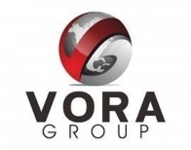
Executive Overview

Confidential

Contents
1 Intent 4
2 History 4
3 Purpose, Vision and Mission 5
4 2006-2020 Track record 6
5 Group Capabilities / Experience 7
6 Summary 8

Confidentiality Notice / Disclaimer

Vora Ventures LLC, along with Candid Ventures LLC and its affiliates, (from herein after “The Vora Group”).

This document outlines the executive overview of the Vora Group including its purpose, mission, vision, and strategy to make one of the most successful venture studio models in the world. It includes the group’s history of humble beginnings, series of innovations and ventures, capabilities and values. Intent of sharing is to explore to work together and create a mutually beneficial partnership.

Copyright © The Vora Group. All rights reserved. All product and company names mentioned herein are trademarks or registered trademarks of their respective owners.

Intent
This document outlines the executive overview of the Vora Group including its purpose, mission, vision, strategy to make one of the most successful venture studios in the country, history, summary of projects and ventures, capabilities and values. Intent is to explore possibilities and create a mutually beneficial partnership. Copyright © The Vora Group. All rights reserved. All product and company names mentioned herein are trademarks or registered trademarks of their respective owners.

History
Vora Group is a Cincinnati, Ohio, USA based Technology Group Creating Entrepreneurial Successes and Jobs Worldwide for the past 18+ years using a unique Venture Studio model.

- Vora follows a Venture Studio model to start, acquire (joint venture), and/or invest in high potential, seed and early stage Digital Transformation companies and achieves high growth through organic execution and strategic M&As.
- The Group is 100% privately owned and manages a portfolio of IT ventures in software, online platforms (B2B B2B2C and B2C), cloud/security infrastructure and IT services.
- Vora is comprised of 3500+ talented innovation engineers, designers, product managers, marketing and business and strategy professionals worldwide. With our scrappy but professional style and our fail fast-fail cheap philosophy has enabled us to deliver “purpose driven innovation at speed”.
- The Group’s very strong, conservative, and thoughtful strategy is evidenced by its proven track record over 18 years and has allowed it to enjoy exponential growth (41% CAGR), despite the financial downturns in 2008-10 and covid 2020-21.
- Mahendra Vora, Executive Chairman and Founder of the Vora Venture Group, has seen great success in building and selling leading technology companies with/to Fortune 500 Companies and stays actively involved in the daily success of his operating companies. Mahendra personally assists his companies with the Innovation, Strategy, and Brand (Culture & Values) building and plays an active
- At Vora, typical seed investment starts at $500k and we invest up to $25MM in additional capital to facilitate organic growth of our ventures.
- Vora fosters family-oriented work environment, multiple time winner of “best places to work” and “cool places to work”. Top industry leaders from across USA an India (like Dr. Yousuf Ahmad, Kevin Dooley, Anu Vora, Kris Nair, Mike Jones and others) lead and run the Group. Vora operates with a strong Purpose to impact the innovation economy, creating opportunities for all through equality and diversity.
- Vora is strongly committed to the Cincinnati and Gujarat, its two homes, giving back to the community and encouragement of employee involvement in the community.
- Vora is known for its win-win, creative, flexible engagement models working with partners, corporations and other inventors.

Purpose, Vision and Mission
Our Core Purpose and mantra is to “do good and do well” using technology as enabler.

We strongly believe that technology can improve life, provide opportunities that we didn’t have before, help people with their health and well-being and help companies create better ecosystem for their consumers and partners, among others.

Our single goal is to positively impact Innovation Economy in our home regions and create future opportunities for our next generation to come back to their home. We believe Innovation, Creating Jobs and fostering Partnerships is the way, we all Rise Together.

Our Personal Values - We operate on strong personal value – The 5 C’s of Vora
- Character – basic integrity
- Commitment – work hard!
- Competence – work smart!
- Courage – take responsibility for what you did.. stand up for what you believe
- Community – Give back, take care of others in surrounding, once you take fo you and your own
Our Business Values - We are known for our unique business / entrepreneurship values: Our Chairman established these 15 years ago and we live by these every day. We call it The Uncommon Sense.
- Frugality with class
- Aggression with ethics
- Creativity with process
- Quality with speed
- Humility with confidence
- Strategy with action
- Success with family

DOING GOOD - Our Community Involvement – Vora as a company and all of its executives/employees are actively involved and engaged in supporting and enhancing our community.
- INTERalliance – Vora was one of the original 5 founders of INTERAlliance along with P&G; 12 years on board, impacting thousands of students, creating opportunities in the IT/STEM sector. Creators of TechOlympics.
- 500+ jobs created for the City of Hamilton – Founder one of the largest tech parks (Vora tech Park) , created 100’s of jobs, over 4%+ increase in per capita income for the city.
- Served as an active member on the Cincinnati Chamber of Commerce Boards with many P&G executives
- Fouding Chairman of the Board for Compass along with P&G executives on the board – to welcome, support and assist the immigrant community
- Jain Center – Trustee & Board member – practicing non-violence and live and let live principles.
- Active member and contributor of United Way – winner of the largest contributor among startups in 2018
- Chairman, Vora Charity Action Committee (VCAC) – involved in helping underprivileged families and children with volunteering, tutoring, supporting programs like crayons to computers etc.

2006-2020 Track record
Vora has enjoyed an impeccable track record on DOING WELL side along with its DOING GOOD goals, over the past 30 years; first 12 as a founder, CEO of multiple successful startups and since 2006, as the Chairman of one of the fastest growing Venture Studios in the world (The Vora Group).

- Involved in 25+ Tech Startups (Many as Founder, CEO – Some as Investor/Director)
- 50+ merges, acquisitions and joint venture projects
- Created over 25,000 Jobs (Through Vora Companies)
- 100% Track Record of Success with all Investors in the Vora Companies – No investor or corporate investment partner (through direct investment or JV), has ever lost money with Vora (To-date)

- Highlights of companies / projects:

1987-1992 Inter-Computer Communications (ICC) – Sold to DCA
1992-1997 Pioneer Systems (Sold to Unisys Corporation)
1997-1999 SecureIT – Sold to Verisign (NASDAQ: VRSN)
1997-2006 Intelliseek (Sold to AC Nielsen (Nielsen Buzzmetrics)
2001-2018 Vinimaya (Aquiire) – Now part of COUPA
2001-2014 Marshal8e6 – Now part of Singapore Telecom
2005-Current Vora Technology Park – Data Centers for Kroger
2008 -Current Ascendum
2009-Current Zakta
2010-Current Koncert IT (started as joint venture with Kroger)
2011-Current Vora Innovation Center (home for Vora Labs)
2013 -Current CenterGrid (cloud infrastructure and data centers)
2014-Current AssureCare (one of the largest heath-tech’s in Ohio)
2017-Current ShakeDeal (leading eCommerce destinations in India)
2018-Current iPatientCare (patient and healthcare-provider solutions)
2018-Current Hinge (eCommerce Enabler for Consumer Brands)
2019-Current TalentNow (Talent Marketplace for the future-of-work)
2020-Current Enhalo (a JV with CyberQ, UK, for internet security services)
2021-Current Mindfully (the fastest growing mental health provider in the USA)

Group Capabilities / Experience
Vora is comprised of some of the best tech-minds, located in Cincinnati, London and Bangalore. Vora has experience in working with F5000 clients and partners, as a developer, joint venture partner or in other creative strategic models. Vora has done close to 100+ transactions in starting new ventures, building, selling and creating IP with organizations reputable worldwide.

- Technology (Software Development) Expertise:
  - Scalable application development for enterprise-class or large consumer conception
  - Deep expertise on full stack (JAVA) development, .NET framework, enterprise-integration, iOS and Android app development, portals, workflow automation, in simple, intuitive user experience.
  - Agile and scrum-based development processes with strong manual and automated QA

- Design Excellence – UI/UX, Portals, Consumer Sites and Mobile Apps:
  - 100+ designers for UI/UX or product design and UI/UX
  - Design Excellence Center in London, and Cincinnati
  - Worked on 100’s of retail and consumer brands (500+)

- AI/ML/Data-Science – Workflow Automation, ChatBots, Self-serve and fuzzy matching
  - Strong team of data scientists with our own automation platform for workflow automation, chatbot creation, Machine Learning based matching and predictions algorithms; working on complex healthcare, consumer, call center automation and talent / workforce matching applications

- Retail, PG and Consumer Experience – Building consumer facing solutions for some of the well-known brands in the nation
  - Multiple organizations within Vora serve retail and CPG sector ranging from creating content (product design/graphics) to building destination sites/mobile-apps
  - Ascendum, Hinge and ShakeDeal deliver retail, consumer commerce solutions
  - 500+ projects/clients under belt over the past 01 years

- HealthCare Innovation – Building innovative technology and services to address the issues of quality and affordability of healthcare around the world (highly inefficient healthcare in USA and lagging quality and standards in other parts of the world).
  - Multiple organizations within Vora serve healthcare vertical with a variety of products and services from technology to network of providers.
  - Over 1000 professionals at Vora are focused on healthcare.
  - AssureCare, Mindfully, Evolve Health, iPatientCare, Curis and others are some of the Vora HealthCare portfolio companies.
  - World renowned population health leader Dr. Yousuf Ahmad lead Vora HealthCare
  - 40+ million patients are served by Vora HealthCare companies through tech/services.

- Business Development and Go-to-market Capabilities – revenue generation through building right sales, marketing, business development and partnerships teams, culture and processes
  - Goal is 10x the ROI from sales/BD compared to market norms by using a highly pragmatic, efficient and targeted go-to-market approach
  - Ex-Amazon, P&G, Kroger, Convergys, large-healthcare companies, management
  - Agile, simple processes focused on reducing realization cycle

- Back Office – HR, Finance and Legal
  - 50+ people in our back-office serving HR, finance and legal needs of our ventures and projects

- Equity Value Creation including Mergers, Acquisitions and Technology/IP Purchases
  - Probably the most-well known for this capability in the region
  - Our down-to-earth midwestern culture and Frugality with Class philosophy enables us to “fail fast, fail cheap” and create value with far less capital compared to typical Westcoast based VC/PE backed ventures
  - Our employees have ownership in what we do – creating a personal mission to create success and deliver value to our clients, employees, partners and shareholders
  - We thrive on meeting challenges and “defying odds” – have many examples of success where others found them unattainable

Summary
Vora Group has been practicing “Innovation as Business” in the information technology sectors for 30+ years in Cincinnati, USA, with many notable successes.

We are known for our innovation with many technology firsts, our quality with speed execution and building successful startups and JV’s with unique business models yielding success for all stakeholders including our community.

We are known for our execution capability, with “do what you say and say what you do”, and our true s win-win partnership model.

OUR DESIGN EXCELELNCE AND DESIGN TEAM IN CINCINNATI (HINGE)



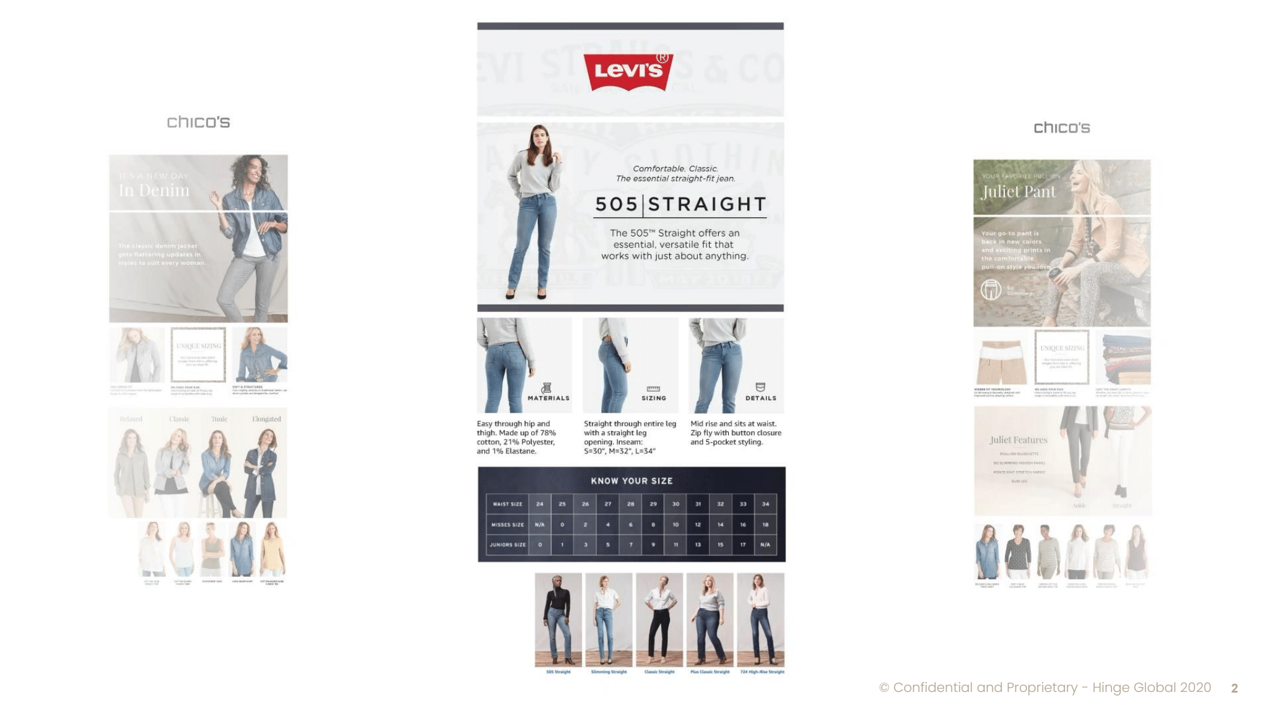

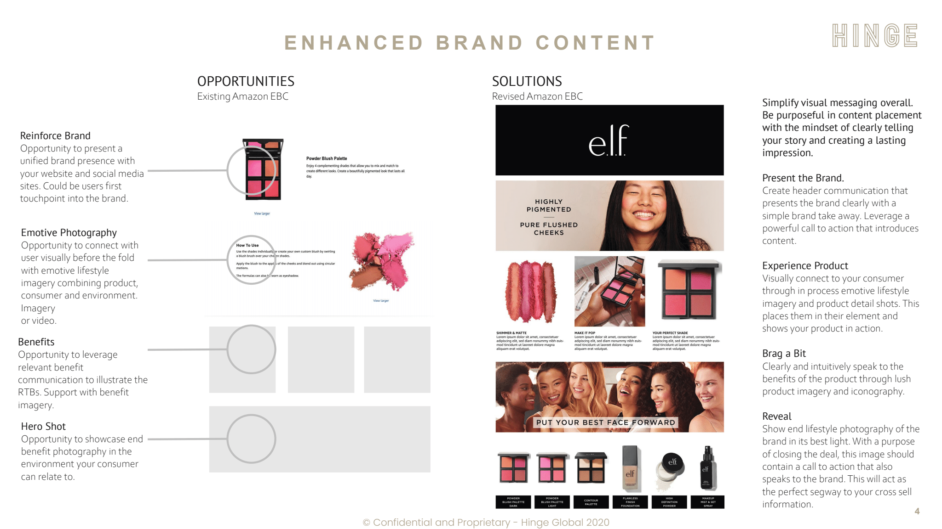

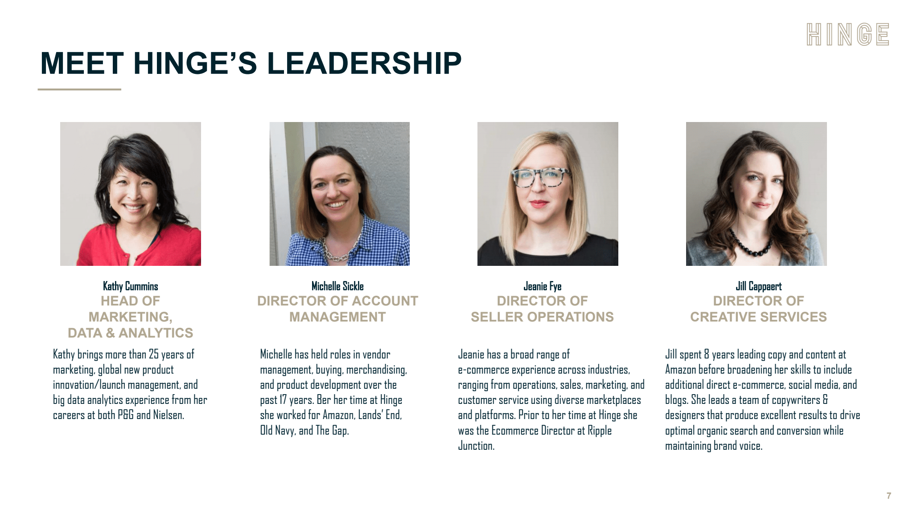

OUR DIGITAL TRANSFORMATION DESIGN CENTER IN LONDON (ASCENDUM)



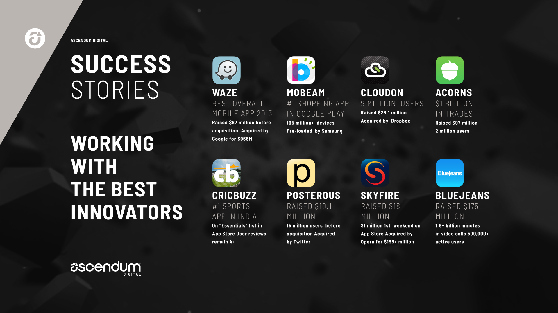


HINGE GLOBAL Partners With NielsenIQ To Offer CPG Companies End-to-End eCommerce Solutions
CINCINNATI, April 15, 2021 /PRNewswire/ -- HINGE GLOBAL, an industry-leading full-service eCommerce agency, has joined the NielsenIQ Connect Partner Network, the largest open ecosystem of solution providers for retailers and manufacturers in the consumer packaged goods (CPG) industry. The HINGE GLOBAL + NielsenIQ partnership provides eCommerce expertise and omnichannel insights to CPG manufacturers.

HINGE GLOBAL, an industry-leading full-service eCommerce agency, has joined the NielsenIQ Connect Partner Network. This partnership pairs the eCommerce expertise and technology software of HINGE GLOBAL with the analytic insights provided by NielsenIQ. Now Consumer Packaged Goods (CPG) companies can tap into the data, operational experience, and technology of both organizations to help drive their eCommerce and traditional retail businesses.
HINGE GLOBAL + NielsenIQ partnership provides deep eCommerce expertise and omnichannel insights to CPG manufacturers.
Tweet this
NielsenIQ is the worldwide leader in measurement and data analytics, providing the most complete and trusted view available of consumers and markets worldwide. HINGE GLOBAL is a leading full-service eCommerce agency, with a staff of experienced eCommerce specialists and proprietary technology to accelerate online sales and help manage every facet of digital commerce operations. In particular, HINGE GLOBAL has cultivated deep expertise in Amazon, Walmart.com, Target+, and other global marketplaces. HINGE GLOBAL has a proven track record managing over 150 brands and $600 million in total gross online sales.
"We are thrilled about the strategic partnership between NielsenIQ and HINGE GLOBAL. Our services are highly complementary, combining the power of HINGE's eCommerce expertise with Nielsen's traditional retail and omnichannel insights. Together we are helping large and small CPG companies optimize their multichannel retail strategies," said Fred Killingsworth, CEO of HINGE GLOBAL.
To learn more, reach out to contact@hingeglobal.com, or visit hingeglobal.com.
About NielsenIQ:
NielsenIQ is the leader in providing the most complete, unbiased view of consumer behavior, globally. Powered by a ground-breaking consumer data platform and fueled by rich analytic capabilities, NielsenIQ enables bold, confident decision-making for the world's leading consumer goods companies and retailers.
Using comprehensive data sets and measuring all transactions equally, NielsenIQ gives clients a forward-looking view into consumer behavior in order to optimize performance across all retail platforms. NielsenIQ has operations in nearly 100 markets, covering more than 90% of the world's population. For more information, visit www.nielseniq.com.
About HINGE GLOBAL:
HINGE GLOBAL is a full-service eCommerce agency, delivering profitable online sales growth on Amazon, Walmart.com, and other marketplaces. HINGE GLOBAL helps brands accelerate their digital commerce by delivering end-to-end solutions including business analysis, paid advertising, digital creative content, and online business operations. For more information, visit www.hingeglobal.com.
Media contact: kathycummins@hingeglobal.com

